* Input a text in the console.
* Count the number of times the "abc" pattern appears in a string.

1. What will be the **result** for these outputs?

|  |  |
| --- | --- |
| **Input** | **Output** |
| abbcdef |  |
| abcfabc |  |
| adabcfbc |  |

1. Choose the more relevant blocks and draw your structure flowchart.
2. Adapt code from a previous session to solve this problem.

* Input a text in the console, only number.
* Multiple all the number before the first apparition of 6 and 1 if 6 is in the first position.

1. What will be the **result** for these outputs?

|  |  |
| --- | --- |
| **Input** | **Output** |
| 123456789 | 120 |
| 5263 | 10 |
| 71256 | 0 |
| 45 | 20 |
| 625 | 60 |

1. Draw your structure flowchart.
2. Use the following code and adapt it so as not to use the repetitive (for) loop.

word = input()

i = 0

mult = 1

while i < len(word) and int(word[i]) != 6:

mult *= int(word[i])

i += 1

print(mult)

* Input a number.
* Display numbers from 1to that number

|  |  |
| --- | --- |
| **Input** | **Output** |
| 4 | 1 2 3 4 |
| 2 | 1 2 |
| 5 | 12345 |
| 3 | 123 |
| 0 | 0 |

1. Create a flowchart to solve this problem. Which loop block will you choose and why?

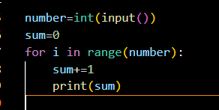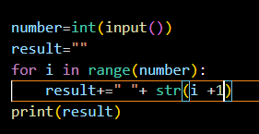

1. Review the code and find **the error** and explain them.

number = int(input())

result = ""

for index in range(number):

result = result + " " + str(index + 1)

print(result)

1. Write your own good code to solve this problem. This time, you can’t use the **for condition**.